**1.Prometheus Installed and Running**

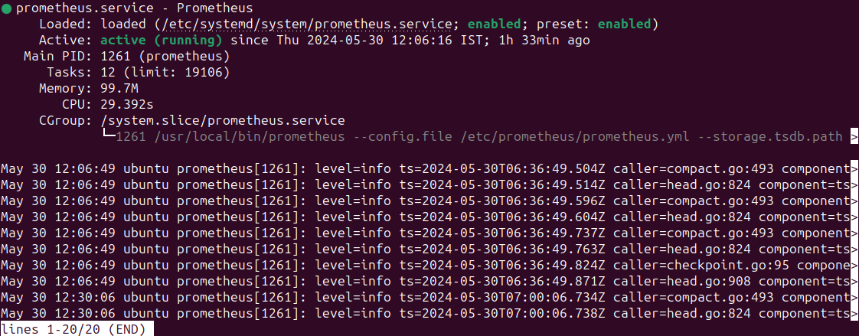

**2.Opened Port number 9090 for Prometheus**



**4.Node Exporter installed and Running**

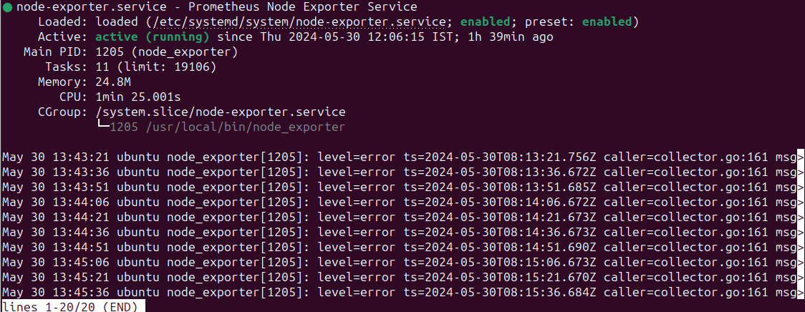

**5. Opened Port number 9100 for Node Exporter**



**6. Node Exporter Running in Port number 9100**

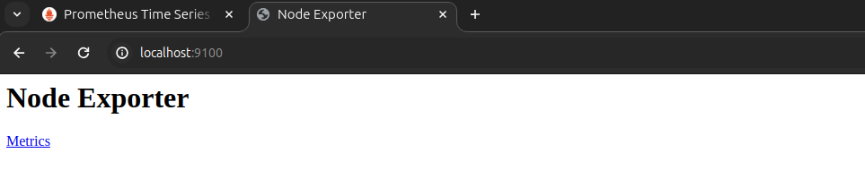

**7.Node exporter IP configured in Prometheus for Target**

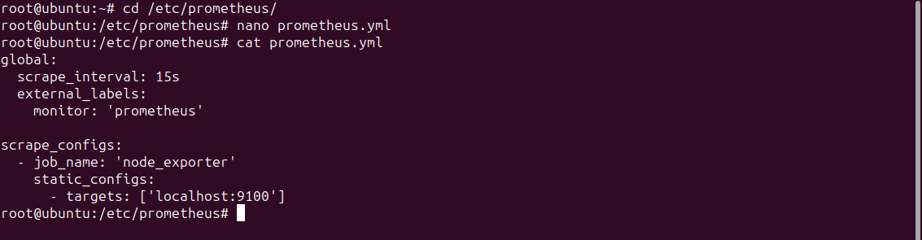

**8.Prometheus restarted for Target configuration**

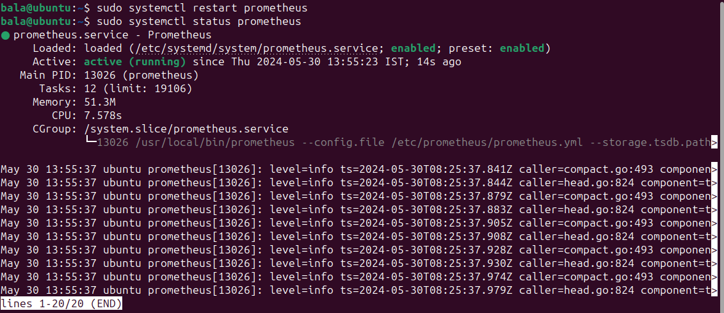

**9.Now our node exporter is added in Prometheus Dashboard**

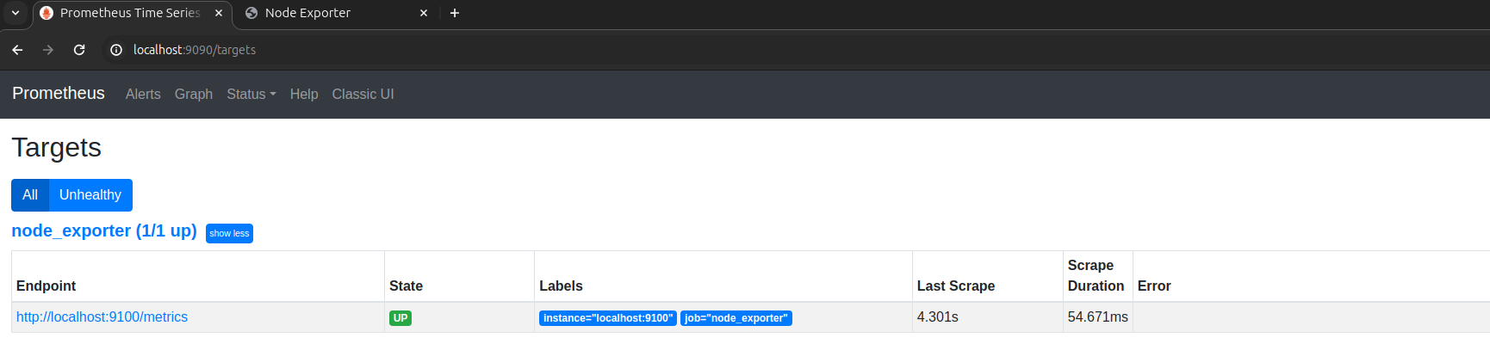

**10.Installed Grafana and Running**

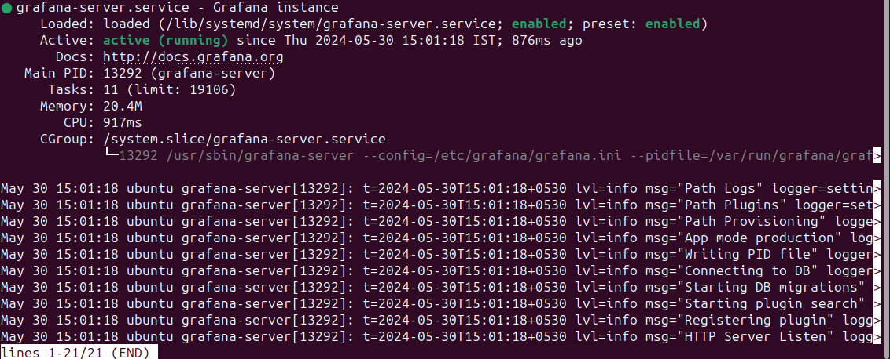

**11. Opened Port number 3000 for Grafana**



**12. Grafana Running in Port Number 3000**

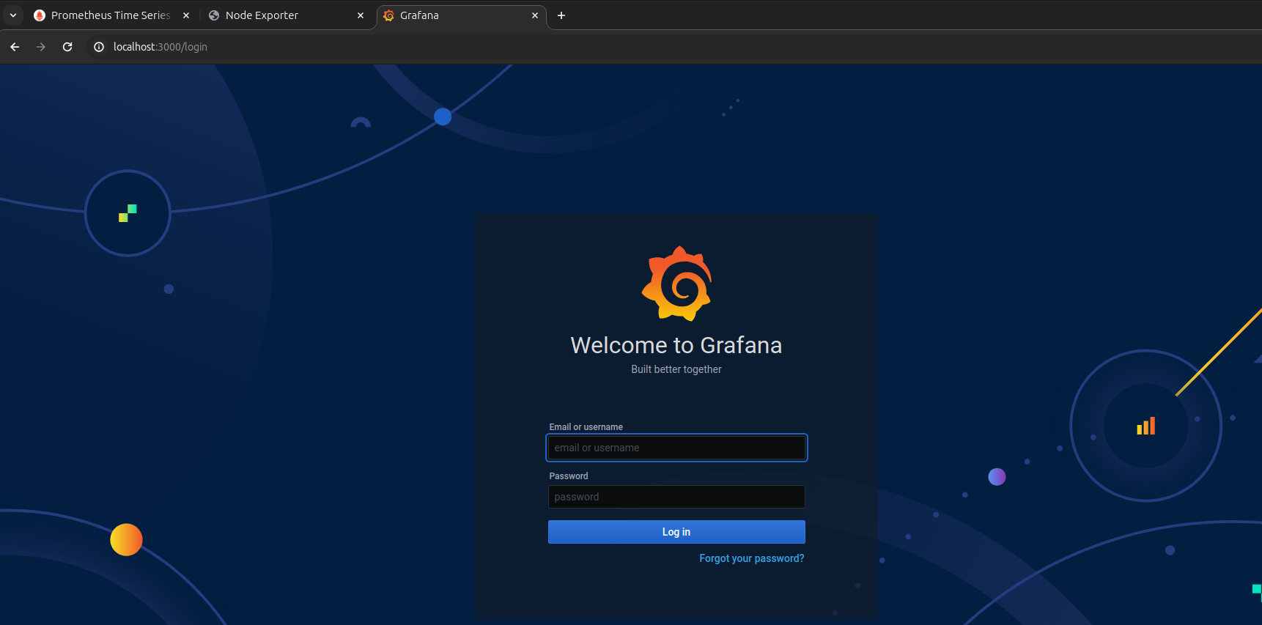

**13.Coneected Prometheus Data Source to Grafana**

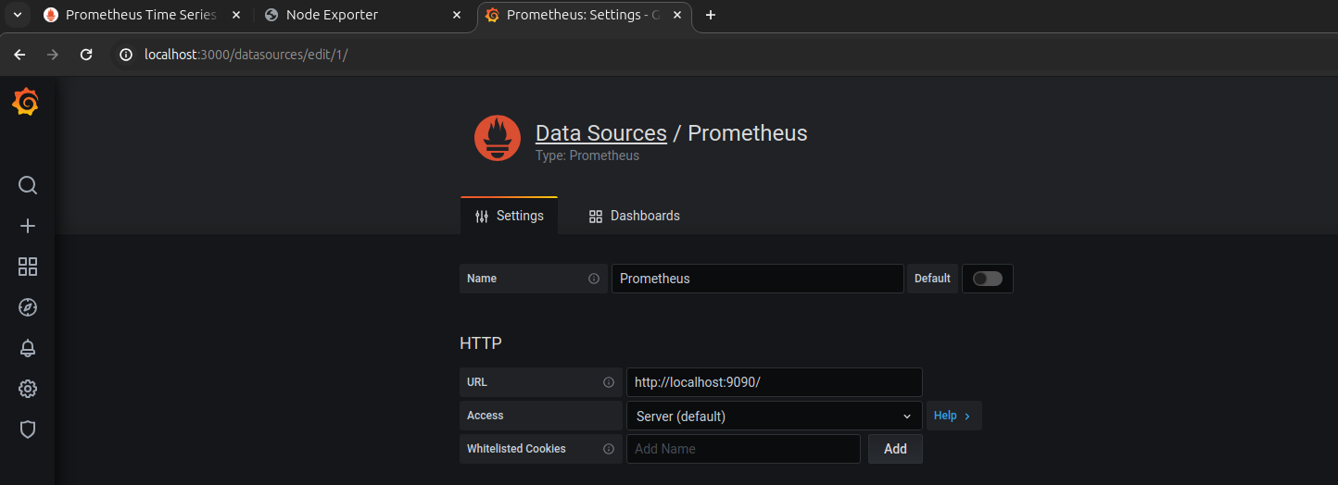

**14. Data Source added and tested. Linked data source is working.**

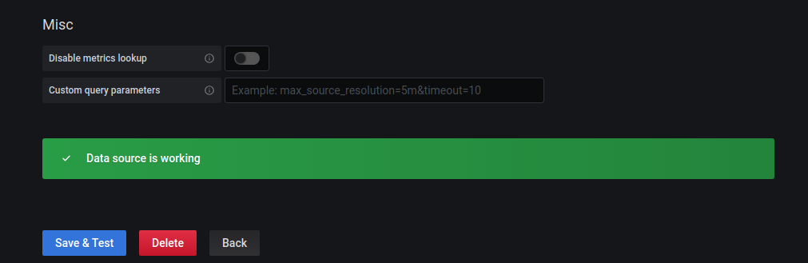

**14.Custom Dash Board Creation**

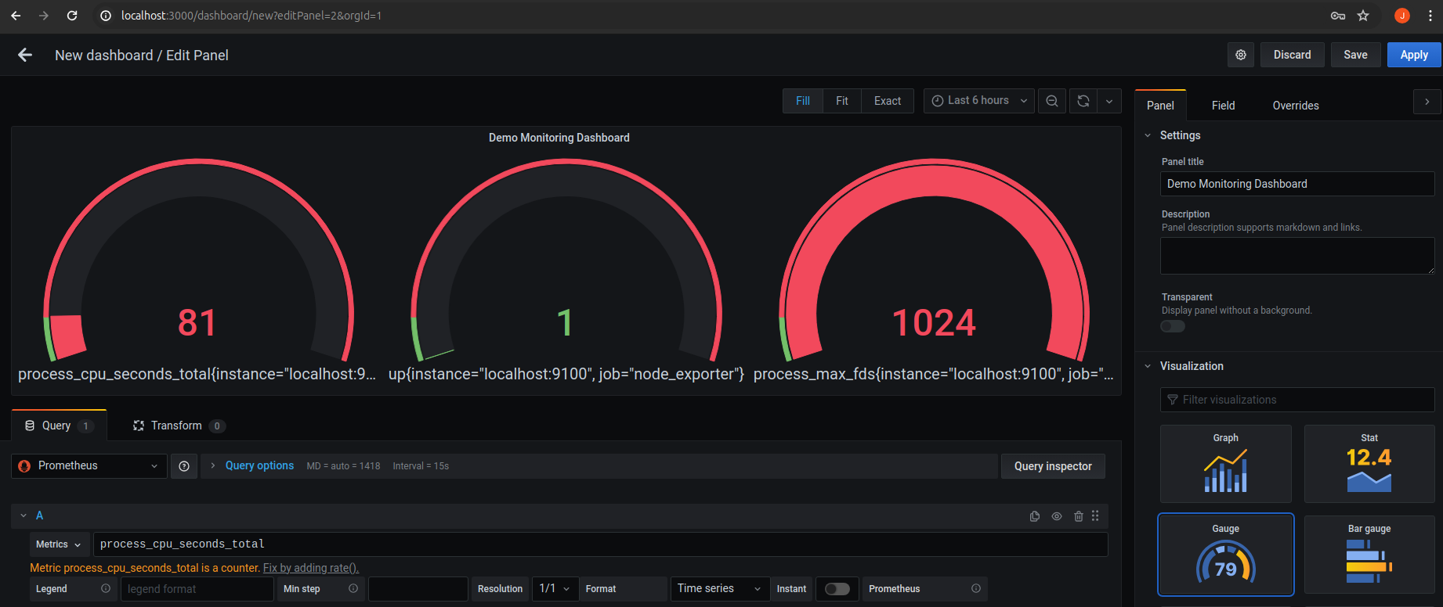

**15. Created New Custom Dash Board**

